

The effectiveness of ASMR on the reduction of anxiety in Neurodivergent participants compared to Neurotypical participants.

Being a dissertation submitted for the Dissertation Module in partial fulfilment of the requirement for a degree of

BSc (Hons) Psychology

Megan J. Griffin 2025
Abstract
Autonomous Sensory Meridian Response (ASMR) has been shown to improve wellbeing throughout various studies, in particular anxiety and stress (Park & Lim, 2022; Eid et al., 2022; Firmansyah et al., 2023). However, little research has been done to assess the effectiveness of this phenomenon as a therapeutic method. Recent articles have suggested using ASMR as a tool to support people with ADHD and Autism to manage their symptoms (Galante & Alam, 2019; Sharky, 2023). Since the issues that ASMR appear to improve seem to be problems that are associated with neurodivergent individuals, this study aimed to investigate the effects of ASMR in reducing anxiety levels in neurodivergent individuals compared to those who are neurotypical. The study was an online pre-to post intervention that 62 participants took part in, who completed the ASRS, AQ-10, DSRS, STAI (pre and post) and watched a 10-minute ASMR YouTube video selected by popular triggers from the ASMR Trigger Checklist (Poerio et al., 2023a). Results showed that anxiety levels were significantly lower after the ASMR intervention than before in all participants. Interestingly, there was not a significant difference between neurodivergent and neurotypical participants in anxiety scores. These findings have important implications for the use of ASMR as a therapeutic method in the future on individuals who are neurodivergent. Future research should put more emphasis on Misophonia and running pre-assessment tests on anxiety scores to reduce distress experienced by participants.

Table of Contents

Abstract ii
Acknowledgements v
- Introduction 1
- Method 6
Sample 6
Measure 6
Procedure 8
Ethics 8
Data Analysis 9
- Results 9
- Discussion 12
- References 18
Appendices 24
Appendix A - Ethical Approval Email 24
Appendix B - Ethical Approval Letter 25
Appendix C - Pre-Intervention Questions 26
Appendix D - Post-Intervention Questions 26
Appendix E - List of Qualitative Answers 27
Appendix F - T-test SPSS Output: Anxiety 28
Appendix G - ANCOVA SPSS Output: Neurodivergent (questionnaire) 29
Appendix H - ANCOVA SPSS Output: Neurodivergent (self-report) 30
Appendix I - T-test SPSS Output: ASMR Experiencers 30
Appendix J - T-test SPSS Output: Gender 31
List of Tables and Figures
Table 1: Table of neurodivergent and neurotypical statistics 11
Table 2: Table of Measures Cronbach’s Alpha α scores 11

Acknowledgements
First and foremost, I would like to thank Dr Lynn Pickerell and Luke Galloway for all their assistance and guidance throughout my Dissertation Project. Thanks to them, I have felt confident in my abilities to grow enough to write this dissertation project, as well as moving on to do my masters in Psychological Research Methods. They have provided me with such support, and I have been so grateful for their kind words and positive affirmations throughout this journey.
My thanks are also to Dr. Giulia Poerio, who I had the chance to discuss ASMR research with. I felt so motivated by the meeting we had, and it pushed me to be able to complete this project. Much of your research has been the reason why I am able to do this project now as you paved the way for the field and began a new chapter in modern research that fascinates many people over the world!
And, Dr Craig Richard, thank you for giving me the opportunity to promote my research on your website ‘ASMR University’. This website you have created is a project I can tell is built on passion and the TED talk you did is so informative for those beginning their delve into ASMR.
I’d like to extend my thanks to my partner, Max Hurst, who has been there to support me throughout everything that has happened this year, even when I thought I wouldn't complete it, and my friend Hibah Hussain who reminded me that we should all be so grateful for the opportunity to be here, creating something we are so passionate about.
I’d like to thank all of those who took part in my research. None of it would have been possible without all the people that took part and helped me promote it.
Finally, for my Great Grandad Bailey who passed away during April 2025 whilst I was completing my final year, may you rest in peace, and I hope you are so proud of me for completing my degree. Like Dr Patrick Hylton said to me, your memories will live on in all of those who knew of you, and all the stories we share.

Introduction
Background of ASMR
ASMR (Autonomous Sensory Meridian Response) is a widely popular phenomenon involving emotional and sensory processes, where specific sensory stimuli (ASMR triggers) evoke feelings of relaxation and a tingling, static-like sensation in the head, back of the neck and shoulders (Barratt & Davis, 2015; Smith et al., 2020). This static-like sensation is otherwise known as ‘tingles’, described by Richard (2019) as a shiver you get down the back of your neck/ head/ shoulders in scenarios such as getting your hair cut, during an eye exam and when your friend whispers a secret in your ear.
The term ASMR was first coined in 2010, by Jennifer Allen (Richard, 2024), and the first piece of empirical research on ASMR was published in 2015 (Barratt & Davis, 2015).
Even though this phenomenon has been researched for less than two decades, ASMR has become an in demand topic of academia, with increasingly more research being published in this field, and the popularity soaring as millions are watching on websites such as YouTube, TikTok and Reddit, it is known currently to be the third most searched term on YouTube worldwide since 2020 (Hardwick, 2020; Cardillo, 2024).
Recently, research has been completed to investigate how ASMR, a phenomenon that has become so quickly popular online, occurs and explored the definitive of who experiences ASMR, what triggers it, and where it happens.
So far, research has concluded that ASMR is a non-universal experience which approximately 1 in 5 people have reported to feel (Poerio et al., 2022a) and ASMR is not just an online phenomenon, but it occurs as an in-person, physical experience (Poerio et al., 2023a). This suggests that not all people will get to experience this feeling in their lifetime, but those who do experience it will often come across the feeling in their day to day lives, such as at the opticians, dentist, during a massage, or talking quietly to a friend (Richard, 2024).
Research has been done on what triggers ASMR by Fredborg et al. (2017), who suggested a 5-factor structure for ASMR: watching, touching, repetitive sounds, stimulations and mouth sounds; suggesting that ASMR is multisensory and involves layering of different triggers.
However, this study was suggested to not have a broad enough spectrum of the stimuli that trigger ASMR, as these ‘triggers’ can be an individual preference as well as context specific (Poerio et al., 2023a). Therefore, in more recent years, Poerio et al. (2023a) created the ASMR Trigger Checklist (ATC), which expanded off the previous model by Fredborg et al. (2017), to assist researchers in ASMR- responder identification and details that ASMR depends on various contexts, and that ASMR videos online imitate and exaggerate real-life settings in which ASMR can occur.
From this study, the most popular triggers recorded were physical touch to the body, soft speaking, whispering, brushing sounds, delicate hand movements and touch to face, which 90% or more of 90 self-reported ASMR-responders agreed to being on the checklist (Poerio et al., 2023a). Other closely popular triggers (which scored 80% and above) were tapping, close personal attention, being cared for, nature, page turning, scratching, rubbing, letter sounds and close-up movements (Poerio et al., 2023a).
However, the least commonly endorsed triggers were having a light flash in one’s face (45%), eating sounds (46%) and blowing (55%), which the researchers suggested may be more context specific than other triggers (Poerio et al., 2023a). These may be less popular among ASMR experiencers as they trigger Misophonia, which is a condition where people experience a strong dislike and angry emotion in response to specific sounds such as chewing and eating (Poerio, 2020).
Many researchers have suggested through empirical evidence that ASMR is similar to many pre-existing concepts including Synthesesia (Poerio et al., 2022a), Mindfulness (Barratt & Davis, 2015; Smith et al., 2020; Fredborg et al., 2018; Scofield, 2019), and Music (Poerio, 2020; Kovacevich & Huron, 2018; Lochte et al., 2018).
The similarities that ASMR has on various components include changes in physiological responses (Kovacevich & Huron, 2018), reductions in heart rate (Poerio, 2020), changes in brain activation (Lochte et al., 2018), the increased focus on positive emotions triggered by the event (Barratt & Davis, 2015), improving mood in depressed participants (Barratt & Davis, 2015), and links to Misophonia (Scofield, 2019).
ASMR Benefits to Wellbeing
As well as this, ASMR has been found to have positive improvements on wellbeing such as self-reported feelings of relaxation, calm and wellbeing (Barratt & Davis, 2015; Poerio, 2016; Poerio et al., 2018; McErlean & Banissy, 2017), sleep quality and ability to fall asleep (McErlean & Banissy, 2017; Lee et al., 2019; Park & Lim, 2022; Woods & Turner-Cobb, 2023), stress (Barratt & Davis, 2015; McErlean & Banissy, 2017; Poerio et al., 2018; Park & Lim, 2022) and anxiety (Park & Lim, 2022; Eid et al., 2022; Firmansyah et al., 2023).
Furthermore, ASMR has even demonstrated that it changes our physiology by decreasing heart rate and skin conductance (Seifzadeh et al., 2023) and activation changes in the brain (Poerio et al., 2018; Lochte et al., 2018).
However, little research has been done to assess the effectiveness of this phenomenon as a therapeutic method.
Neurodivergent Individuals
For example, a group of individuals who would benefit the most from an available, at-home, free therapeutic method are adults who are neurodivergent. Neurodivergent is an umbrella term for those whose selective neurocognitive functions and/or neurodevelopmental differences fall outside prevalent societal norms (Shah et al., 2022). They do not necessarily have a neurodevelopmental disorder but do include individuals whose brain function and/or cognition differ to those who are neurotypical (a person who has neurocognitive functions within societal norms) (Shah et al., 2022). These can be people who are diagnosed with attention deficit hyperactivity disorder (ADHD), Autism (ASD), dyspraxia, dyscalculia, cognitive functioning difficulties and Tourette syndrome (NHS, 2023).
Unfortunately, many people who are neurodivergent, such as individuals with ADHD and ASD specifically, struggle with higher rates of comorbid illnesses than neurotypical people, such as substance abuse disorders, depression, psychosis, OCD, sleep disorders, general anxiety disorders (GAD) and Tourette's syndrome (Groenman et al. 2017, Kessler et al. 2006, Lee et al. 2011; Barlattani et al., 2023).
One of the most common comorbid disorders in people with ADHD and ASD is Anxiety and Stress (Kent & Simonoff, 2017; Garcha & Smith, 2023; Lackschewitz et al., 2008; Bishop‐Fitzpatrick et al., 2015). For example, Reimherr et al. (2017) conducted a study on people with ADHD diagnosed and compared clinical samples to those diagnosed with a General Anxiety Disorder (GAD), which suggested approximately 25% of people with ADHD also have a GAD disorder. In people with ASD, Kent and Simonoff (2017) suggest that 42-79% of young people with ASD have an anxiety disorder. This suggests that anxiety is having a massive impact on young adults who are neurodivergent, potentially limiting their ability to function within societal norms.
To investigate this, another study by Garcha and Smith (2023), used a series of online questionnaires on over 430 students, including the AQ-10 and ASRS. The results showed significant correlations between anxiety, depression, ASD and ADHD traits.
ASMR on Neurodivergent Individuals
Recent articles have suggested the exploration of ASMR as a treatment method for individuals who are neurodivergent as this may help decrease symptoms and/or manage heightened levels of anxiety (Galante & Alam, 2019; Sharky, 2023; Common, 2024).
Galante & Alam (2019) were the first individuals to suggest the use of ASMR as an intervention for people with ASD. They suggested that ASMR may aid people with Autism in dealing with emotional self-regulation and meltdowns as the calming nature of it may reduce anxiety as seen in neurotypical individuals.
Similarly, Sharky (2023) suggested the use of ASMR on individuals with ADHD may be beneficial or potentially damaging. To further explain, the article delves into the links between ASMR and ADHD, such as biological links, sensory sensitivity and that the problems ASMR have been suggested to combat are problems associated with ADHD. This article ends by suggesting that ASMR will be experienced at a higher frequency in people with ADHD compared to neurotypical people.
Also, Common (2024) mentions that ASMR could be used on an individual basis to help manage behaviours in people with ADHD.
Issues on use of ASMR
However, these articles also emphasize that there are also arguments as to why ASMR may not be enjoyed in individuals who are neurodivergent.
For example, Misophonia, which is commonly experienced when watching ASMR in people who experience it, is higher in individuals who are neurodivergent than those who are neurotypical. This is potentially due to a higher percentage of neurodivergent individuals possessing hypersensitivity or hyposensitivity, also known as abnormal sensory processing (Panagiotidi et al., 2018; Horder et al., 2014). Therefore, this must be considered, as Misophonia can cause highly uncomfortable experiences, potentially putting many neurodivergent individuals in distress (Sharkey, 2023).
However, being aware of these potential issues should not detract researchers from investigating the potential benefit of ASMR research on people who are neurodivergent.
Current Understanding
Our current understanding of the links between using ASMR on individuals who are neurodivergent are:
- There is a link between sensory sensitivity in ASMR experiencers and Neurodivergent individuals.
For example, Roberts et al., (2021) and Poerio et al., (2022b) suggest from their findings that ASMR is related to being highly sensitive. Furthermore, Poerio et al. (2022b) showed that ASMR responders have higher levels of sensitivity than non-responders in all the High Sensitivity Person subscales. Similarly, hypersensitivity is a trait that's common in individuals with ADHD and ASD (Ghanizadeh, 2011; Schulz & Stevenson, 2019). This suggests that ASMR may work well on neurodivergent individuals as they are often hypersensitive.

- There is a link to the symptoms neurodivergent people experience and the reductions that ASMR have been shown to create
ASMR has been shown to improve anxiety, wellbeing, mood in depressed participants, sleep quality and the ability to fall asleep and stress (Barratt & Davis, 2015; McErlean & Banissy, 2017; Lee et al., 2019; Park & Lim, 2022; Woods & Turner-Cobb, 2023; Poerio et al., 2018; Eid et al., 2022; Firmansyah et al., 2023). The positive benefits are shown throughout many studies, that can all be interlinked to one thing when thinking about neurodivergent individuals, which is comorbid disorders. Individuals with ADHD and ASD very often have comorbid disorders such as an anxiety disorder which in many cases impacts the individual's wellbeing, mood, sleep quality, ability to fall asleep and stress levels (Bonti et al., 2024). Therefore, this suggests that ASMR may be an excellent intervention when attempting to target neurodivergent people in reducing their symptoms/ anxieties.

- There is a small link between the brain regions activated
Research has shown that ASMR experiencers have a reduced functional connectivity or atypical patterns of connectivity in the Default Mode Network (DMN), salience, visual, central executive and sensorimotor networks (Poerio et al., 2018; Smith et al., 2019). This possibly links with ADHD as the DMN (which is linked to distractibility) is more active in people with ADHD (Hallowell, 2021). Potentially indicating a way of reducing activity in the DMN of individuals with ADHD, thus reducing their symptoms.
To summarize, there are currently only suggestions of what ASMR is capable of as a potential therapeutic method based upon what we currently know of its calming and soothing benefits. However, we can link the potential benefit ASMR has onto people who are neurodivergent through these various factors. Research should be done to further investigate ASMR as a therapeutic method on individuals who are neurodivergent.
Aims and Hypotheses
Therefore, the aim of the study is to investigate the short-term effects of ASMR in reducing anxiety levels in people who are neurodivergent and those who are neurotypical.
The second aim of the study will be to assess the post-ASMR anxiety scores for any gender differences.
The expected results will be that there are:
- Lower post-ASMR anxiety scores from all participants compared to the pre-ASMR anxiety scores.
- The intervention will affect participants who are neurodivergent differently to participants who are neurotypical.
- ASMR responders will report lower levels of post-ASMR anxiety levels compared to non-responders.
- The intervention will affect male participants differently to female participants.
Method
Sample
A total of 137 participants submitted answers, however 75 participants were removed as they did not complete the study. Therefore, the end sample size was 62.
The 62 participants who took part were aged 18-64 (M = 28.89, SD = 12.26). The self-reported gender split was 38 female, 18 male and 6 people who self-identified as other genders. Most of the sample were White (45) UK residents (46), with other participants coming from various other ethnicities (17) and countries (16).
The recruitment of participants included posters around the University Campus, social media accounts and forums. Furthermore, the study was posted on ‘asmruniversity.com', as consent to post this was gained by the website owner, Dr. Craig Richard. Recruitment of participants includes volunteer sampling and snowball sampling.
Measure
The online study was created using Question Pro and consisted of the following: demographic questions, the ADHD Self Report Scale (ASRS; Kessler et al., 2005), the Autism Spectrum quotient (AQ10; Allison et al., 2012) the Daily Stress Response Scale (DSRS; Debowska et al., 2022), the State-Trait Anxiety Inventory (STAI; Spielberger, 1970), a 10-minute ASMR YouTube video (Diddly ASMR, 2023), and pre- and post-video questionnaire. None of these following pre-existing measures have been modified or shortened for the purpose of the study.
ADHD Self-Report Scale: (ASRS; Kessler et al., 2005)
The ASRS is a short format self-report questionnaire, consisting of 18 items, that was designed to assess ADHD in adults. All the questions are consistent with the DSM-V (APA, 2013) criteria, which have been worded to reflect symptomology in adults (Kessler et al., 2005). There are two parts to the questionnaire, but only part A was used, which consists of questions regarding the 6 most predictive questions for assessing ADHD. An example of part A questions is “How often do you feel overly active and compelled to do things, like you were driven by a motor?". The ASRS items are all measured on a 5-point Likert scale where 0 = ‘Never’ and 5 = ‘Very Often’. A score of 4 or higher on Part A represents symptoms associated with ADHD that is usually considered for a diagnostic assessment (Waite et al., 2022). The ASRS has established in previous studies good reliability in clinical and community samples (Adler et al., 2006).
AQ-10: (AQ10; Allison et al., 2012)
The AQ-10 is a short format self-report questionnaire used to aid decision-making in the referral of people who may have Autism to get fully tested (Allison et al., 2012). The 10 items are divided into 5 subscales that include Attention to detail, Attention Switching, Communication, Imagination and Social. An example of a statement from the questionnaire is ‘If there is an interruption, I can switch back to what I was doing very quickly’. The AQ-10 items are all measured on a 4-point Likert scale where 1= ‘Definitely agree’ and 4= ‘Definitely disagree’. Four of the items are scored regarding higher responses indicating a symptom of Autism, and the other six are reverse scored, so that lower responses indicate a symptom of Autism. Anyone scoring 6 or more is usually considered for a specialist diagnostic assessment of Autism clinically. Cronbach’s α values for the AQ-10 adult version, which is what we are using for this study, was .85 from the original paper (Allison et al., 2012). Also, the questionnaire was significantly correlated (r = .92, p = .0001) with the longer questionnaire, the AQ-50 (Allison et al., 2012).
Daily Stress Response Scale: (DSRS; Debowska et al., 2021)
The DSRS is a 30-item scale consisting of two subscales, psychological and physiological stress response (15 items each respectfully). It aims to measure psychological and physiological stress reactions that can be used to assess the stress response to daily stressors. An example of the psychological stress items is ‘I have been feeling overwhelmed’ and an example of the physical stress items is ‘I have had abdominal pains’, where higher responses indicate a greater level of stress. The DSRS items are all measured on a 5-point Likert scale where 1 = ‘Never’ and 5 = ‘Nearly all the time’. Cronbach’s α values for psychological stress is .95 and for physiological stress is .91 from the original paper (Debowska et al., 2021).
State-Trait Anxiety Inventory: (STAI; Spielberger, 1970)
STAI aims to assess state and trait-level anxiety, using 10 items each. An example of these items is ‘I feel secure’ and ‘I feel nervous’. All these items are measured on a 4-point Likert scale, with 1 = ‘Not at all’ and 4 = ‘Very much so’, where higher scores indicate a greater level of anxiety. Half of the items on the test are reverse scored, and the overall score of state and trait anxiety is calculated from summing up the items for each scale. The questionnaire has a total score ranging from 20 to 80 (Spielberger, 1970). Cronbach’s α values for the STAI has been found to range from 0.71 - 0.85 in studies using University students (Maynard et al., 2010; Vitasari et al., 2011; Stojanović et al., 2020).
Intervention: (Diddly ASMR, 2023)
A 10-minute Audio-visual ASMR video by Diddly ASMR (2023) was used for the study https://www.youtube.com/watch?v=DsIm6SgUihQ . This video was carefully selected after investigating various videos as the requirements for the video were for the ASMRtists to be speaking/whispering in some way and abided to the popularity of ASMR triggers from Poerio et al. (2023a) study in the ATC. Also, researchers excluded triggers from Poerio et al. (2023a) ATC checklist as these triggers potentially have a higher chance of producing misophonia.
Therefore, the selected video for this study includes personal attention, hand movements, tapping, singing bowl, whispering, letter sounds, touch to face, close-up movements as triggers instructions within a 10-minute timeframe (to consider inattentiveness in neurodivergent individuals).
ASMR Pre-condition Questions:
Three questions were used to assess participants' self-reported levels of neurodivergent. The other question has been taken from Poerio et al. (2023b) study where the researchers used a question to classify participants as ASMR responders and non-ASMR responders.
ASMR Post-condition Questions:
Questions were used after the study to gain a more in-depth insight into how ASMR made the participants feel, with two of the questions being open-ended.
Procedure
Participants were directed to the Question Pro link/ QR code where they read the Participant Information Sheet and completed the Consent form.
Once the study began on Question Pro, participants were requested to fill in some Demographic Information regarding their age, gender, ethnicity and place of residence.
Then, participants self-reported on ASD using the AQ-10, ADHD using the ASRS, anxiety using the STAI and stress using the DSRS.
Before listening to the ASMR video, participants will be asked some pre-condition questions and then asked to find a location that was away from people, quiet and wear headphones/ earbuds to maximize the chance that ASMR was experienced (Kovacevich & Huron, 2018).
Once this task was completed, participants were asked to do the STAI again and then the post-condition questions.
Once this was completed, participants were debriefed online and thanked for taking part.
The study took approximately 30 minutes to complete.
Ethics
The current study received ethical approval from the University of Lincoln School of Psychology Research Ethics Committee (Ethics approval Code: 2025_19310)
To reduce harm and distress, information was given to participants about the sensitive nature being explored around mental health, as well as the risks of misophonia being triggered and empathized that people with psychosis could not take part.
Data Analysis
The design used for this study is a pre-to post intervention. The data was scored and analyzed in SPSS IBM (Version 28). The tests conducted were independent samples T-test and One-way repeated measures ANCOVA. The data met all assumptions for the parametric tests – observations were independent, and sample groups were random.
The pre-ASMR STAI scores and the post-ASMR STAI scores were inputted in a t-test to find out if there is a significant effect between anxiety before and after the ASMR video. STAI measures were compared with neurodivergent scores using an ANCOVA, with DSRS subscales being the covariate to assess the difference between anxiety scores in neurodivergent and neurotypical participants. T-tests were run on STAI measures, with ASMR experiencers and gender.
The study aimed at a statistical power of 80% to detect an effect of 25% with an alpha of .05 in an ANCOVA. This G*Power analysis (Faul et al., 2007) suggested 128 participants were required, and the study did not fulfill these conditions. A post hoc was conducted as the sample size was not met. Sixty-two participants were collected, which indicated a power of .49, suggesting the sample had low power.
Results
Descriptives
Within the participating group, 47 were self-reported as experiencing ASMR and 15 participants indicated as never experiencing ASMR. The details of participants’ neurodivergent scores are in Table 1 and details regarding the measures used in this study including Cronbach Alpha scores are in Table 2.
Independent Samples T-test
Participants’ anxiety scores were compared before and after the intervention. On average, participants had lower anxiety after the intervention (M = 40.27, SD = 12.54) than before (M = 46.79, SD = 6.35). A Paired-Samples t-test indicated this difference, 6.52, 95%CI [3.11, 9.91] was statistically significant, t (61) = 3.84, p < .001. The effect size was small, d = .49.
Repeated Measures ANCOVA of Neurodivergent Participants (Questionnaire)
A One-way analysis of covariance (ANCOVA) was run to establish whether post ASMR condition exam scores differed between the neurodivergent group and the neurotypical group while controlling for Physiological and Psychological stress. The distinguish of neurodivergent and neurotypical participants in this ANCOVA were based upon the level scored on AQ-10 and ASRS.
Preliminary checks were completed to assess the assumptions of normality and homogeneity of variance. A Shapiro-wilk test indicated that post condition anxiety scores were normally distributed in the neurodivergent participants W (39) = .96, p = .15 and neurotypical participants W (23) = .98, p = .86. Levene’s test indicated that the assumption of homogeneity of variance was not violated, F (1, 60) = 0.01, p = .911.
After controlling for physiological and psychological stress, post-anxiety scores were not significantly higher in the neurotypical group (M = 42.57, SD = 6.32) compared to the neurodivergent group (M = 42.62, SD = 6.09), F (1, 58) = .70, p = .406, ηp² = .012.
Psychological stress was not significantly related to post-condition anxiety scores, F (1, 58) = 1.48, p = .228, ηp2 = .025. Physiological stress was not significantly related to post-condition anxiety scores, F (1, 58) = 1.68, p = .200, ηp2 = .028.
Repeated Measures ANCOVA of Neurodivergent Participants (Self-report)
A One-way analysis of covariance (ANCOVA) was run to establish whether post ASMR condition exam scores differed between the neurodivergent group and the neurotypical group while controlling for Physiological and Psychological stress. The distinguish between neurodivergent and neurotypical participants in this ANCOVA were based upon the self-reported ADHD and ASD scores.
Preliminary checks were completed to assess the assumptions of normality and homogeneity of variance. A Shapiro-wilk test indicated that post condition anxiety scores were normally distributed in the neurodivergent participants W (31) = .95, p = .18 and neurotypical participants W (31) = .98, p = .84. Levene’s test indicated that the assumption of homogeneity of variance was not violated, F (1, 60) = 2.23, p = .141.
After controlling for physiological and psychological stress, post-anxiety scores were not significantly higher in the neurotypical group (M = 42.32, SD = 6.84) compared to the neurodivergent group (M = 42.87, SD = 5.42), F (1, 58) = .00, p = .986, ηp2 = .000.
Psychological stress was not significantly related to post-condition anxiety scores, F (1, 58) = .991, p = .32, ηp2 = .017. Physiological stress was not significantly related to post-condition anxiety scores, F (1, 58) = 1.59, p = .21, ηp2 = .027.
Independent Samples T-test on ASMR Experiencers
Pre-anxiety scores of ASMR experiencers and non-experiencers were compared. On average, ASMR experiencers (M = 47.09, SD = 6.51) scored higher than non-experiencers (M = 45.87, SD = 5.91). An independent-samples t-test indicated this difference, 1.22, 95%CI [-2.57, 5.00], was not statistically significant, t(60) = .64, p = .52.
Post-anxiety scores of ASMR experiencers and non-experiencers were compared. On average, ASMR non-experiencers (M = 43.40, SD = 8.11) scored higher than ASMR experiencers (M = 42.34, SD = 5.43). An independent-samples t-test indicated this difference, -1.06, 95%CI [-4.71, 2.59], was not statistically significant, t(60) = -.58, p = .56.
Independent Samples T-test on Gender
Pre-anxiety scores of males and females were compared. On average, men (M =47.47, SD = 7.68) scored higher than women (M = 46.55, SD = 5.99). An independent-samples t-test indicated this difference, .92, 95%CI [-2.79, 4.63], was not statistically significant, t(55) = .497, p = .62.
Post-anxiety scores of males and females were compared. On average, women (M = 43.63, SD = 5.75) scored higher than men (M = 39.68, SD = 6.68). An independent samples t-test indicated this difference, -3.95, 95%CI [-7.37, -.53], was statistically significant, t(55) = -2.31, p = .02.
Table 1
Table of neurodivergent and neurotypical statistics
Neurodivergency | Self-Report |  | Questionnaire’s
Neurodivergency | N | % | N | %
Neurodivergent | 31 | 50 | 39 | 62.9
Neurotypical | 31 | 50 | 23 | 37.1
Total | 62 | 100 | 62 | 100

Table 2
Table of Measures Cronbach’s Alpha α scores
Measure | Items | Cronbach’s Alpha α | M | SD
AQ-10 | 10 | .74 | 4.90 | 2.59
ASRS (Q1-6) | 6 | .88 | 3.70 | 1.82
STAI (pre) | 20 | .54 | 46.79 | 6.35
DSRS Psychological | 15 | .94 | 43.63 | 12.63
DSRS Physiological | 15 | .94 | 31.58 | 12.83
STAI (post) | 20 | .94 | 40.27 | 12.54
Cronbach’s Alpha α Overall: M = 28.48, SD = 19.41

Discussion
Summary
The research issue addressed in this study was filling the gap on using ASMR as a potential therapeutic tool in individuals who are Neurodivergent by comparing them to Neurotypical individuals. This study assessed whether anxiety levels would be decreased in individuals who are Neurodivergent and Neurotypical. This study finds that ASMR does in fact decrease Anxiety levels in all participants, but there is no difference in whether participants are neurotypical or neurodivergent, suggesting that ASMR should be used as a therapeutic tool to reduce anxiety for both groups.
Hypothesis Answered
From the study, the results of a T-test suggest that there is a significant difference between anxiety scores before the ASMR video and afterwards in all participants. The means show that on average, there was a decrease (-6.52) of anxiety after watching the ASMR video, supporting our first hypothesis that ASMR reduces anxiety for short-term. Some of the qualitative data backs this up from individuals commenting, ‘I’m feeling very calm’, ‘...all in all I felt relaxed’ and ‘the tapping of the fingers made me feel calm’. This suggests that ASMR can be assumed to be an effective tool for reducing short-term anxiety in adults. These findings are in line with previous research (Park & Lim, 2022; Eid et al., 2022; Firmansyah et al., 2023; Seifzadeh et al., 2023).
However, not everyone enjoyed the video, as there were various comments describing the negative experiences participants felt during the video including ‘I found the video extremely unpleasant to watch. I only managed a few seconds’, ‘ASMR makes me feel uncomfortable and unpleasant’, ‘aural discomfort’, ‘the video gave me anxiety’. These comments are important to highlight as even though statistically there is a significant difference in decreased levels of anxiety, not all of the participants felt that way. For example, these participants may be hypersensitive to specific sounds caused from the triggers (Misophonia) or may not experience ASMR.
Also, a previous study suggested that watching ASMR alleviated anxiety but only in ASMR experiencers, which contradicts what we have found here since on average, both ASMR experiencers and non-experiencers had decreased levels of anxiety (Eid et al., 2022). Since both the current study and this one have similar sample sizes, an assumption for this disparity in results may be down to target during recruitment. For example, in this current study individuals who were prone to Misophonia were advised not to participate as ASMR is common for Misophonia occurring, therefore less people may have taken part who find ASMR displeasing as they were debriefed in the Participant Information Sheet to not participate or withdraw if they began feeling too uncomfortable. Another reasoning is that the ASMR video in this study was specifically selected due to the specific triggers included as to not trigger misophonia to the best of our abilities.
The results of ANCOVA show that there was not a significant difference between post-ASMR anxiety scores in Neurodivergent participants compared to Neurotypical participants, which does not support the second hypothesis. As previously stated, anxiety has decreased in participants overall, meaning that this anxiety has decreased in participants with ADHD and ASD (the neurodivergent condition).
Considering our understanding of the concepts, it is not surprising that ASMR decreases anxiety in people with ADHD as ASMR is known for engaging roleplay videos, that encourage viewers to relax and unwind to a combination of new and different audio and visuals, capturing the attention of people with ADHD, helping to distract these people from any negative and restless thoughts they may experience during time periods of restlessness and hyperactivity.
Therefore, the unsignificant result should not be viewed as a bad thing, rather than using ASMR as a therapeutic method to reduce anxiety in neurodivergent individuals is something we should do, but we should also use ASMR as a therapeutic tool for neurotypical individuals too.
A couple of reasons for this non-significant difference may be that ASMR overall has a positive impact on those who (1) experience it and (2) who do not have Misophonia, which may be reasons for a non-significant result. It is also important to note that the study did not collect a sufficient sample size to meet the requirements of the A*priori G-Power analysis, which was 128. Therefore, when running the post-hoc, the power was only .49 which is far too low to be able to consider using the results to apply them to the real world.
However, based upon previous articles discussing ASMR as a therapeutic method, I believe that this supports their claims to complete pre-assessments for Misophonia before using ASMR, as this may be a large factor in whether ASMR is calming and therefore reduces anxiety or not (Galante & Alam, 2019).
Since this is the first study to complete research on ASMR and neurodivergent participants, there is no previous research to support or oppose the findings.
The results from the t-tests suggest that anxiety levels (before and after) of ASMR experiencers are not significantly different to ASMR non-experiencers. This does not support the third hypothesis, or research by previous studies as they found a significant difference between ASMR experiencers and non-experiencers in anxiety alleviation (Eid et al., 2022).
But an interesting point to note about these scores is that ASMR experiencers (M=47.09) have a non-statistically difference between pre anxiety scores to non-experiencer (M = 45.87), which upon looking at these scores could indicate that ASMR experiencers may possess higher baseline levels of anxiety than non-experiencers, which would actually still support the suggested findings of previous research (Eid et al., 2022). It is important to note that this result is non-significant and other research must be conducted before taking this result further.
Upon looking at the results from the last t-test, there was a significant result between gender and post-ASMR anxiety scores. The results showed that men (M = 39.68) had significantly lower post-ASMR anxiety scores than women (M = 43.63), suggesting that even after an anxiety reduction, there are disparities between the genders. This supports our fourth hypothesis.
The main reason for this that comes to mind is that women on average, have been found to have significantly higher levels of anxiety than men (Bahrami & Yousefi, 2011), which may implicate their results in comparison to men. Another reason could be that there were not many male participants in the research compared to women, so the data may be skewed. Also, this could be due to the gender of the ASMRtist in the ASMR video used as she was a woman, which could potentially have an impact on anxiety scores.
There is no current evidence in previous literature to support differences between anxiety levels and gender. However, the qualitative data does not support the results as one male participant writes ‘From the clip I was feeling vexed, it made me angry, and I couldn't say why. I felt like a perv or creap (creep) listening and watching a young woman ... it wasn't for me’. This suggests that he found watching a young lady uncomfortable, and it potentially caused him to become more anxious. This may be due to the participant being an older man than the woman in the video, which raises the question on if there are gender and age differences on the type of ASMR used towards different groups of individuals.
Implications
The present study’s consideration of various factors throughout the designing process was vast. In particular, there was much consideration when selecting a specific ASMR video to use within the study. This began with the decision on how long a video would be for the intervention. As research was being conducted on participants who have ADHD, the video could not have been too long in length as people with ADHD do not have long attention spans, therefore the video length was no more than 10 minutes. Then, when deciding on the triggers included within the intervention, Poerio’s ATC model (2023a) was used to pick popular triggers and to avoid unpopular ones that may cause Misophonia such as eating sounds. Therefore, the intervention considered various individuals needs from the ASMR video.
Also, STAI has previously been used to assess anxiety levels before and after watching an ASMR video in a piolet study by Seifzadeh et al. (2024), which found that there was a decrease in state anxiety after watching ASMR videos, increasing the reliability of the results.
On top of that, the study has used both quantitative results to investigate any significant differences and qualitative results to look at participant perceptions of the ASMR video. This have given us some great insights, as a few of the participants noted that there were a few mouth sounds within the video that made them feel uncomfortable or trigger misophonia, which is surprising as there was lots of consideration in the video chosen for the intervention. Therefore, using both methods of data collection has given the results a greater depth of understanding and reliability.
If the results suggest that ASMR has a positive impact on anxiety reduction in both neurodivergent and neurotypical individuals, this suggests that ASMR therapeutic methods should be used to target people with high levels of anxiety, rather than specifically neurodivergent individuals since on average, all participants benefited from the ASMR condition. Also, one main suggestion these results covey is that it is more important to pre-assess misophonia when using ASMR as a therapeutic method, supported by the suggestions of Galante & Alam (2019). Therefore, if funding is limited resources should focus on the use of misophonia pre-assessments.
Furthermore, targeting individuals who struggle with anxiety may be beneficial when applying ASMR as a technique. For example, for those in the UK who are waiting for medical assistance with their mental health in services, in particular counselling, there can be lengthy waiting periods until a counsellor is assigned of around 18 weeks (Punton et al., 2022). Also, if someone were to require medication for something such as ADHD, which is highly comorbid with anxiety, these waiting times can sometimes be years, as the diagnosis process is lengthy (Reimherr et al., 2017; NHS, 2025). Whilst waiting for these backlogs of ‌people to be dealt with, some people turn to private care, but that is expensive. Therefore, the use of ASMR would be beneficial to reduce anxiety in patients whilst waiting for referrals, as ASMR is freely accessible at any time through places like YouTube and Reddit.
Another point to note is if there are gender differences between anxiety reduction after watching ASMR videos, then certain ASMR may be more effective for women and other for men. For example, the current study found men were less anxious after watching the ASMR intervention used, which was of a younger woman. If this is the case, then ASMR videos should be recommended to individuals as a context-specific fit.
Limitations
One of the biggest limitations for this study was the sample size. As we have previously mentioned the study did not collect the sufficient sample size to meet the g-power analysis, which means that when running the post-hoc, the power for the study was very low. This means that the results may not be truly significant, and caused by factors outside the researchers control since there are not enough participants to reliably compare the results to a population. This suggests that all the results in this study need to be taken with caution as they are likely to be distorted and not accurate for the population. On the other hand, recent research argues that post-hoc power analyses are not reliable enough for us to use them, as they can be misleading (Heinsberg & Weeks, 2022).
Another problem the research faces is the lack of validity and reliability of the measures used. For example, the ASRS has not been used within the literature of ASMR as research of neurodivergent individuals has never been conducted on ASMR. This suggests that there is uncertainty around whether this study accurately captures what the measure is intending to measure as we have no evidence from other studies in the field to support the current findings. This decreases the reliability of the results. However, the ASRS has been previously used in studies regarding young people’s experiences of stress (Öster et al., 2020), which is a variable integrated into our study. Also, the Cronbach alpha scores for the ASRS in the current study were .88 which is considered in the ‘good’ range, meaning that the internal consistency of the items in the measure is high. Therefore, this means that the measures are high in internal reliability.
A limitation of the intervention previously mentioned above is that the intervention video still triggered Misophonia in some participants. For example, some of the feedback given from the questions around negative feelings toward the ASMR video explained that there were mouth sounds that made a few of the participants uncomfortable, suggesting that some of the mouth noises that ASMR Diddy uses during the video were too similar to eating noises, creating negative responses in a few of the participants (which may be due to Misophonia). Also, one participant felt uncomfortable watching a younger lady, causing him distress as he felt it made him feel like a ‘perv’. An issue this brought up was that only one, young, female researcher, who experiences ASMR and does not possess misophonia sought out a video to use for the intervention, meaning the video was not checked with other researchers with differences in perspectives (e.g. an older woman who might experience misophonia), therefore there was no inter-rater reliability.
Future Research
Upon evaluation of the study, there are numerous recommended questions for future research to answer and suggestions for any future research carried out in ASMR.
Future research should acknowledge the problems that the current study faces and ensure that there are measures in place to control these problems.
For example, in this study neurodivergence was clustered into one category, however, this oversimplifies a vast group of individuals who possess neurodevelopmental disorders and learning disorders. Therefore, future research should target populations specifically such as ADHD. However, this may be difficult to do when examining multiple neurodevelopmental disorders such as ADHD and ASD as these disorders are often comorbid.
Another suggestion is that ASMR videos should be chosen more carefully with multiple researchers agreeing on a video or series of triggers to reduce impacts like distress or misophonia and increase inter-rater reliability. This will increase control of the ASMR videos when using them throughout future studies.
Future research should investigate different genres of ASMR. To elaborate, this means ASMR with and without people in them, and with different genders of ASMRtists as we found a gender difference for participants and comments supporting a difference in anxiety relief from participants feeling ‘like a creep’ when watching a younger woman.
Most importantly, future research on ASMR and Neurodivergent people should put more emphasis on Misophonia and running pre-assessment tests for things that may limit the benefits of ASMR, supporting the suggestions from Galante and Alam (2019). This is important as the negative experiences received in this study suggest, that Misophonia puts individuals in highly uncomfortable and distressed situations.
Finally, some future questions that need to be answered in the literature are:
- Does ASMR reduce anxiety long-term? (something like Mindfulness Based Stress Reduction program, but with ASMR)
- Are there gender differences in anxiety reduction in ASMR?
- Do the people with ADHD/ASD who are high scoring sensitivity experience ASMR more?
Conclusion
To conclude, ASMR has been shown to have a profound impact on reducing short-term levels of anxiety in people who are neurodivergent and neurotypical. However, these results must be taken with caution due to the small power from the post hoc. This suggests that ASMR can be used as a therapeutic tool to reduce anxiety in both neurodivergent and neurotypical individuals, if pre-assessments are made for anxiety and misophonia.
Words = 6925
References
Adler, L. A., Spencer, T., Faraone, S. V., Kessler, R. C., Howes, M. J., Biederman, J., & Secnik, K. (2006). Validity of pilot Adult ADHD Self-Report Scale (ASRS) to rate adult ADHD symptoms. Annals of Clinical Psychiatry, 18(3), 145-148. https://doi.org/10.3109/10401230600801077
Allison, C., Auyeung, B., & Baron-Cohen, S. (2012). Toward brief “red flags” for autism screening: the short autism spectrum quotient and the short quantitative checklist in 1,000 cases and 3,000 controls. Journal of the American Academy of Child & Adolescent Psychiatry, 51(2), 202-212. https://doi.org/10.1016/j.jaac.2011.11.003
American Psychiatric Association. (2013). Diagnostic and statistical manual of mental disorders (5th ed.). https://doi.org/10.1176/appi.books.9780890425596
Bahrami, F., & Yousefi, N. (2011). Females are more anxious than males: a metacognitive perspective. Iranian journal of psychiatry and behavioral sciences, 5(2), 83-90. https://pmc.ncbi.nlm.nih.gov/articles/PMC3939970/
Barlattani, T., D’Amelio, C., Cavatassi, A., De Luca, D., Di Stefano, R., Di Berardo, A., Mantenuto, S., Minutillo, F., Leonardi, V., Renzi, G., Russo, A., Rossi, A., & Pacitti, F. (2023). Autism spectrum disorders and psychiatric comorbidities: A narrative review. Journal of Psychopathology, 29(1-2), 3–24. https://doi.org/10.36148/2284-0249-N281
Barratt, E. L., & Davis, N. J. (2015). Autonomous Sensory Meridian Response (ASMR): a flow-like mental state. PeerJ, 3, e851. https://doi.org/10.7717/peerj.851
Bishop‐Fitzpatrick, L., Mazefsky, C. A., Minshew, N. J., & Eack, S. M. (2015). The relationship between stress and social functioning in adults with autism spectrum disorder and without intellectual disability. Autism Research, 8(2), 164-173. https://doi.org/10.1002/aur.1433
Bonti, E., Zerva, I. K., Koundourou, C., & Sofologi, M. (2024). The High Rates of Comorbidity among Neurodevelopmental Disorders: Reconsidering the Clinical Utility of Distinct Diagnostic Categories. Journal of personalized medicine, 14(3), 300. https://doi.org/10.3390/jpm14030300
Cardillo, A. (2024, July 21). Top searches on YouTube (2024). Exploding Topics. https://explodingtopics.com/blog/top-youtube-searches
Common, A. (2024, August 4). Why People with ADHD May Hate ASMR: Understanding the Complex Relationship. https://neurolaunch.com/adhd-hate-asmr/
Debowska, A., Horeczy, B., Boduszek, D., Dolinski, D., & von Bastian, C. C. (2021). Development and validation of a stress response measure: the Daily Stress Response Scale (DSRS). Health Psychology Report, 10(3), 238. https://doi.org/10.5114/hpr.2022.116812
Diddly ASMR. (2023, May 19). ASMR Fall Asleep in 10 Minutes [Video]. YouTube. https://www.youtube.com/watch?v=DsIm6SgUihQ
Eid, C. M., Hamilton, C., & Greer, J. M. (2022). Untangling the tingle: Investigating the association between the Autonomous Sensory Meridian Response (ASMR), neuroticism, and trait & state anxiety. PloS one, 17(2), e0262668. https://doi.org/10.1371/journal.pone.0262668
Faul, F., Erdfelder, E., Lang, A.-G., & Buchner, A. (2007). G*Power 3: A flexible statistical power analysis program for the social, behavioral, and biomedical sciences. Behavior Research Methods, 39(2), 175–191. https://doi.org/10.3758/BF03193146
Firmansyah, A., Limasta, I. W., & Tusyakdiah, H. (2023). The Effect of Autonomous Sensory Meridian Response (ASMR) Relaxation on Anxiety in Teenagers. Journal of Psychology Today, 1(2), 107-118. https://digamed.net/index.php/psychologytoday/article/view/171
Fredborg, B., Clark, J., & Smith, S. D. (2017). An examination of personality traits associated with autonomous sensory meridian response (ASMR). Frontiers in psychology, 8, 247. https://doi.org/10.3389/fpsyg.2017.00247
Fredborg, B. K., Clark, J. M., & Smith, S. D. (2018). Mindfulness and autonomous sensory meridian response (ASMR). PeerJ, 6, e5414. https://doi.org/10.7717/peerj.5414
Galante, A., & Alam, N. (2019). Autonomous sensory meridian response as an intervention to autism spectrum disorder. Psychology and Behavioral Science, 13(2), 555859. https://doi.org/10.19080/PBSIJ.2019.13.555859
Garcha, J., & Smith, A. P. (2023). Associations between autistic and ADHD traits and the well-being and mental health of university students. Healthcare, 12(1), 14. https://doi.org/10.3390/healthcare12010014
Ghanizadeh, A. (2011). Sensory processing problems in children with ADHD, a systematic review. Psychiatry investigation, 8(2), 89. https://doi.org/10.4306/pi.2011.8.2.89
Gillmeister, H., Succi, A., Romei, V., & Poerio, G. L. (2022). Touching you, touching me: Higher incidence of mirror-touch synaesthesia and positive (but not negative) reactions to social touch in Autonomous Sensory Meridian Response. Consciousness and Cognition, 103, 103380. https://doi.org/10.1016/j.concog.2022.103380
Groenman, A. P., Janssen, T. W., & Oosterlaan, J. (2017). Childhood psychiatric disorders as risk factor for subsequent substance abuse: a meta-analysis. Journal of the American Academy of Child & Adolescent Psychiatry, 56(7), 556- 569. https://doi.org/10.1016/j.jaac.2017.05.004
Hallowell, E. (2021, June 24). ADHD’s secret demon - and how to tame it. ADDitude. https://www.additudemag.com/default-mode-network-adhd-brain/
Hardwick, J. (2021, Janurary 1). Top YouTube Searches (as of April 2020). Ahrefsblog. https://ahrefs.com/blog/top-youtube-searches/
Heinsberg, L. W., & Weeks, D. E. (2022). Post hoc power is not informative. Genetic epidemiology, 46(7), 390–394. https://doi.org/10.1002/gepi.22464
Horder, J., Wilson, C. E., Mendez, M. A., & Murphy, D. G. (2014). Autistic traits and abnormal sensory experiences in adults. Journal of autism and developmental disorders, 44, 1461-1469. https://doi.org/10.1007/s10803-013-2012-7
Kent, R., & Simonoff, E. (2017). Prevalence of anxiety in autism spectrum disorders. Anxiety in children and adolescents with autism spectrum disorder, (pp.5-32). Academic Press. https://doi.org/10.1016/B978-0-12-805122-1.00002-8
Kessler, R. C., Adler, L., Ames, M., Demler, O., Faraone, S., Hiripi, E. V. A., Howes, M. J., Jin, R., Secnik, K., Spencer, T., Ustun, T. B., & Walters, E. E. (2005). The World Health Organization Adult ADHD Self-Report Scale (ASRS): a short screening scale for use in the general population. Psychological medicine, 35(2), 245-256. https://doi.org/10.1017/S0033291704002892
Kessler, R. C., Adler, L., Barkley, R., Biederman, J., Conners, C. K., Demler, O., Farone, S. V., Greenhill, L. L., Howes, M. J., Secnik, K., Spencer, T., Ustun, B., Walters, E. E., & Zaslavsky, A. M. (2006). The prevalence and correlates of adult ADHD in the United States: results from the National Comorbidity Survey Replication. American Journal of psychiatry, 163(4), 716-723. https://doi.org/10.1176/ajp.2006.163.4.716
Kovacevich, A., & Huron, D. (2018). Two studies of autonomous sensory meridian response (ASMR): The relationship between ASMR and music-induced frisson. Empirical musicology review, 13(1-2), 39-63. https://doi.org/10.18061/emr.v13i1-2.6012
Lackschewitz, H., Hüther, G., & Kröner-Herwig, B. (2008). Physiological and psychological stress responses in adults with attention-deficit/hyperactivity disorder (ADHD). Psychoneuroendocrinology, 33(5), 612-624. https://doi.org/10.1016/j.psyneuen.2008.01.016
Lee, S. S., Humphreys, K. L., Flory, K., Liu, R., & Glass, K. (2011). Prospective association of childhood attention-deficit/hyperactivity disorder (ADHD) and substance use and abuse/dependence: a meta-analytic review. Clinical psychology review, 31(3), 328-341. https://doi.org/10.1016/j.cpr.2011.01.006
Lee, M., Song, C. B., Shin, G. H., & Lee, S. W. (2019). Possible effect of binaural beat combined with autonomous sensory meridian response for inducing sleep. Frontiers in human neuroscience, 13, 425. https://doi.org/10.3389/fnhum.2019.00425
Lochte, B. C., Guillory, S. A., Richard, C. A., & Kelley, W. M. (2018). An fMRI investigation of the neural correlates underlying the autonomous sensory meridian response (ASMR). BioImpacts: BI, 8(4), 295. https://doi.org/10.15171/bi.2018.32
Maynard, D. M. B., Campbell, M. H., Devonish, D., Leon, T., Emmanuel, M. K., & Roberti, J. W. (2010). Psychometric properties and factorial structure of the State Trait Anxiety Inventory-Trait Version (STAI-T) in Caribbean university students. Journal of Psychology in Africa, 20(1), 7-12. https://doi.org/10.1080/14330237.2010.10820337
McErlean, A. B. J., & Banissy, M. J. (2017). Assessing individual variation in personality and empathy traits in self-reported autonomous sensory meridian response. Multisensory Research, 30(6), 601-613. https://doi.org/10.1163/22134808-00002571
NHS. (2023). What is neurodiversity? Cambridge University Hospitals. https://www.cuh.nhs.uk/our-people/neurodiversity-at-cuh/what-is-neurodiversity/
NHS. (2025, March 19). ADHD in adults. https://www.nhs.uk/conditions/adhd-adults/
Öster, C., Ramklint, M., Meyer, J., & Isaksson, J. (2020). How do adolescents with ADHD perceive and experience stress? An interview study. Nordic Journal of Psychiatry, 74(2), 123-130. https://doi.org/10.1080/08039488.2019.1677771
Panagiotidi, M., Overton, P. G., & Stafford, T. (2018). The relationship between ADHD traits and sensory sensitivity in the general population. Comprehensive psychiatry, 80, 179-185. https://doi.org/10.1016/j.comppsych.2017.10.008
Park, S. A., & Lim, H. S. (2022). The effect of ASMR on anxiety, stress, sleep quality in university students. The Journal of the Convergence on culture technology, 8(2), 321-327. https://doi.org/10.17703/JCCT.2022.8.2.321
Poerio, G. L. (2016). Could insomnia be relieved with a YouTube video? The relaxation and calm of ASMR. In Callard, F., Staines, K., Wilkes, J. (Eds.), The restless compendium: Interdisciplinary investigations of rest and its opposites (pp. 119-128). Springer Nature.
Poerio, Giulia L (2020) Autonomous Sensory Meridian Response. In: The International Encyclopedia of Media Psychology. John Wiley & Sons, Inc., pp. 1-7. ISBN 9781119011071. https://doi.org/10.1002/9781119011071.iemp0304
Poerio, G. L., Blakey, E., Hostler, T. J., & Veltri, T. (2018). More than a feeling: Autonomous sensory meridian response (ASMR) is characterized by reliable changes in affect and physiology. PloS one, 13(6), e0196645. https://doi.org/10.1371/journal.pone.0196645
Poerio, G. L., Osman, F., Todd, J., Kaur, J., Jones, L., & Cardini, F. (2023b). From the outside in: ASMR is characterised by reduced interoceptive accuracy but higher sensation seeking. Multisensory Research, 36(7), 661-681. https://doi.org/10.1163/22134808-bja10108
Poerio, G. L., Mank, S., & Hostler, T. J. (2022b). The awesome as well as the awful: Heightened sensory sensitivity predicts the presence and intensity of Autonomous Sensory Meridian Response (ASMR). Journal of Research in Personality, 97. https://doi.org/10.1016/j.jrp.2021.104183
Poerio, G. L., Succi, A., Swart, T., Romei, V., & Gillmeister, H. (2023a). From touch to tingles: Assessing ASMR triggers and their consistency over time with the ASMR Trigger Checklist (ATC). Consciousness and Cognition, 115, 103584. https://doi.org/10.1016/j.concog.2023.103584
Poerio, G. L., Ueda, M., & Kondo, H. M. (2022a). Similar but different: High prevalence of synesthesia in autonomous sensory meridian response (ASMR). Frontiers in Psychology, 13, 990565. https://doi.org/10.3389/fpsyg.2022.990565
Punton, G., Dodd, A. L., & McNeill, A. (2022). 'You're on the waiting list': An interpretive phenomenological analysis of young adults' experiences of waiting lists within mental health services in the UK. PloS one, 17(3), e0265542. https://doi.org/10.1371/journal.pone.0265542
Reimherr, F. W., Marchant, B. K., Gift, T. E., & Steans, T. A. (2017). ADHD and anxiety: clinical significance and treatment implications. Current Psychiatry Reports, 19, 1-10. https://doi.org/10.1007/s11920-017-0859-6
Richard, C. (2024), History of ASMR, http://www.asmruniversity.com, accessed November 3rd, 2024
Richard, C. (2019, November). The brain science (and benefits) of ASMR. TED: Ideas change everything. https://www.ted.com/talks/craig_richard_the_brain_science_and_benefits_of_asmr?subtitle=en
Roberts, N., Beath, A. and Boag, S. (2021). Autonomous Sensory Meridian Response, J. Individual Differences. 42, 124–131. https://doi.org/10.1027/1614-0001/a000337
Schulz, S. E., & Stevenson, R. A. (2019). Sensory hypersensitivity predicts repetitive behaviours in autistic and typically-developing children. Autism, 23(4), 1028-1041. https://doi.org/10.1177/1362361318774559
Scofield, E. (2019). A Quantitative Study Investigating the Relationship between Autonomous Sensory Meridian Response (ASMR), Misophonia and Mindfulness. Manchester Metropolitan University. (Unpublished) https://e-space.mmu.ac.uk/623904/
Seifzadeh, S., Asayesh, V., Nikjeh, M. T., Dehghani, M., Parsa, E. R., & Asgharianasl, F. (2023). The Physiological Effects of ASMR on Anxiety. Frontiers in Biomedical Technologies, 10(4), 459-464. https://doi.org/10.18502/fbt.v10i4.13728
Seifzadeh, S., Kostek, B., & Poerio, G. L. (2024). EEG-based analysis of ASMR Stimuli: a pilot study of neuropsychological responses through conventional vs. bone-conduction headphones. Vibrations in Physical Systems, 35(3), 1-9. https://doi.org/10.21008/j.0860-6897.2024.3.07
Shah, P. J., Boilson, M., Rutherford, M., Prior, S., Johnston, L., Maciver, D., & Forsyth, K. (2022). Neurodevelopmental disorders and neurodiversity: Definition of terms from Scotland's National Autism Implementation Team. The British Journal of Psychiatry, 221(3), 577-579. https://doi.org/10.1192/bjp.2022.43
Sharkey, C. (2023). Autonomous Sensory Meridian Response as a Treatment for Attention Deficit Hyperactivity Disorder. PIT Journal. https://pitjournal.unc.edu/2023/06/14/autonomous-sensory-meridian-response-as-a-treatment-for-attention-deficit-hyperactivity-disorder/
Smith, S. D., Fredborg, B. K., & Kornelsen, J. (2019). Atypical functional connectivity associated with autonomous sensory meridian response: An examination of five resting-state networks. Brain connectivity, 9(6), 508-518. https://doi.org/10.1089/brain.2018.0618
Smith, S. D., Fredborg, B. K., & Kornelsen, J. (2020). Functional connectivity associated with five different categories of Autonomous Sensory Meridian Response (ASMR) triggers. Consciousness and Cognition, 85, 103021. https://doi.org/10.1016/j.concog.2020.103021
Spielberger, C. D. (1970). Manual for the State-Trait Anxiety Inventory (self-evaluation questionnaire). (No Title).
Stojanović, N. M., Ranđelović, P. J., Nikolić, G., Stojiljković, N., Ilić, S., Stoiljković, B., & Radulović, N. S. (2020). Reliability and validity of the Spielberger's State-Trait Anxiety Inventory (STAI) in Serbian university student and psychiatric non-psychotic outpatient populations. Acta facultatis medicae Naissensis, 37(2), 149-159. https://doi.org/10.5937/afmnai37-25011
Vitasari, P., Wahab, M. N. A., Herawan, T., Othman, A., & Sinnadurai, S. K. (2011). Re-test of State Trait Anxiety Inventory (STAI) among engineering students in Malaysia: Reliability and validity tests. Procedia-Social and Behavioral Sciences, 15, 3843-3848. https://doi.org/10.1016/j.sbspro.2011.04.383
Waite, R., Buchanan, T., & Leahy, M. (2022). Assessing ADHD symptoms among young adults in the university with the ASRS v1. 1: Examining associations with social anxiety and self-efficacy. International Journal of Disability, Development and Education, 69(5), 1631-1644. https://doi.org/10.1080/1034912X.2020.1825643
Woods, N., & Turner-Cobb, J. M. (2023). ‘It’s like Taking a Sleeping Pill’: Student Experience of Autonomous Sensory Meridian Response (ASMR) to Promote Health and Mental Wellbeing. International journal of environmental research and public health, 20(3), 2337. https://doi.org/10.3390/ijerph20032337

Appendices
Appendix A
Ethical Approval Email
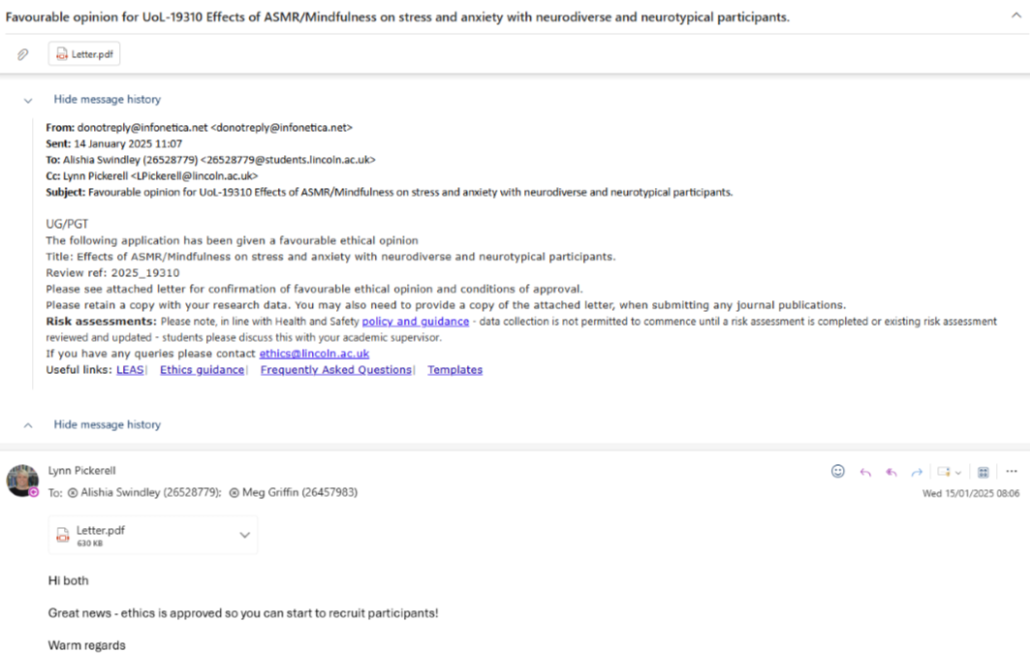

Appendix B
Ethical Approval Letter
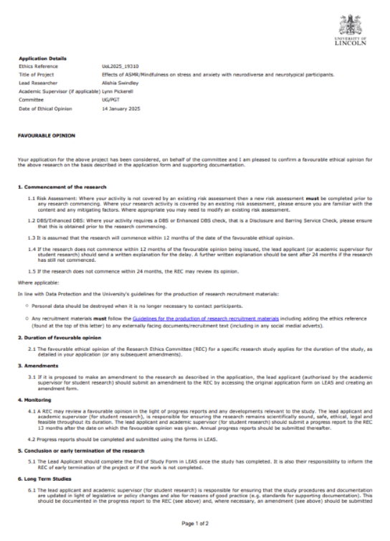
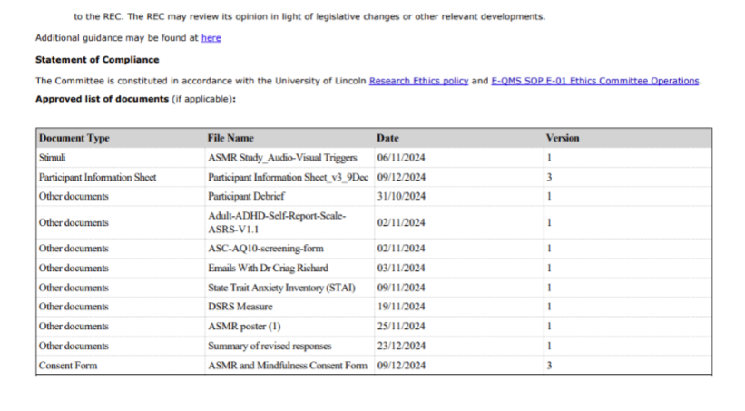Appendix C
Pre-Intervention Questions
1. “ASMR (Autonomous Sensory Meridian Response) is activated during intervals of positive, personal attention (the Context) coupled with a gentle voice, touch, sound, and/or movement (the Triggers). An example of this is tingles in your head and deeply relaxed while getting a haircut, watching bob ross create a painting or that feeling you get in your head and down your back (= tingles) when someone whispers something into your ear. Have you experienced ASMR or tingles?”
2. “Do you identify as having ADHD?”
3. “Do you identify as having ASD?”
4. “Do you have any other form of neurodiversity? If yes, please state which neurodiversity.”
Appendix D
Post-Intervention Questions
1. "How did you feel during the study?"
2. "Did the video help you feel more present in the moment?"
3. "Having now read the ASMR description and watched the video, do you think you experience ASMR?"
4. "Did you experience any negative feelings/emotions from the study? If yes, please explain"

Appendix E
List of Qualitative answers
Participant | Feedback of Negative Experience
1 | ‘From the clip I was feeling vexed, it made me angry and I couldn't say why. I felt like a perv or creap listening and watching a young woman ... it wasn't for me’
2 | ‘I just found it weird to have such sensitive sounds like that moving around my ears. It felt like being tickled somewhat??’
3 | ‘only very very slight winces of annoyance from her doing things with her mouth---most of it was very pleasant but sometimes it can also border on annoying if it sounds almost like one chewing with one's mouth full, which I really hate hearing! There were only a few milliseconds of that however’
4 | ‘I found the video extremely unpleasant to watch. I only managed a few seconds’
5 | ‘I hate asmr whisper videos’
6 | ‘The mouth noises that sounded like she was eating with her mouth open made me mildly uncomfortable but all in all I felt relaxed’
7 | ‘As previously stated just a bit overwhelmed with some of my negative responses to some questions.’
8 | ‘Wildly uncomfortable specifically over the overtly close human sounds, my personal space felt destroyed, i had a ton of impulsive movements throughout either as catharsis / vent or in an effort to get away from the direction the space was coming from, a lot of hands over the ears / face and rapid tapping of surfaces I also immediately was trying to find other things to distract myself with as it went on’
9 | ‘ASMR felt weird and bit uncomfortable.’
10 | ‘I ticked no, but I will say that watching the video (as someone that vaguely knew ASMR as a concept but not the experience) it was quite odd. I kept rationalising the experience in my head as a spirit messing with me as I am someone uncomfortable with very close contact especially with whispering in my ears. But I...'acclimatised' to the fact that this is a video and not a real person beside me I felt fine with the experiment. But I still imagined her voice as a spirit in my head throughout the video when I remembered she existed (I was listening to this while typing stuff)’
11 | ‘Was worried I would answer questions wrong and struggled a bit to sit and focus on it’
12 | ‘I'm feeling very calm’
13 | ‘Asmr makes me feel uncomfortable and unpleasant’
14 | ‘Just the uncomfortable feeling that tongue and mouth noises brought as they were not relaxing, just slightly off putting’
15 | ‘Aural discomfort’
16 | ‘I have not felt negative emotions in the study, although things are going very negative around me’
17 | ‘The video gave me anxiety’
18 | ‘I have misphonia, so the clicking mouth noises made me feel more anxious and unsettled. The tapping of the fingers made me feel calm but when mouth noises started, became unsettled’
19 | ‘Misophonia at the saliva sounds, the singing bowl, and a few seconds of tapping on the egg.’
20 | ‘Just don't like the sounds on the video. Make me feel irritable’

Appendix F
T-test SPSS Output: Anxiety
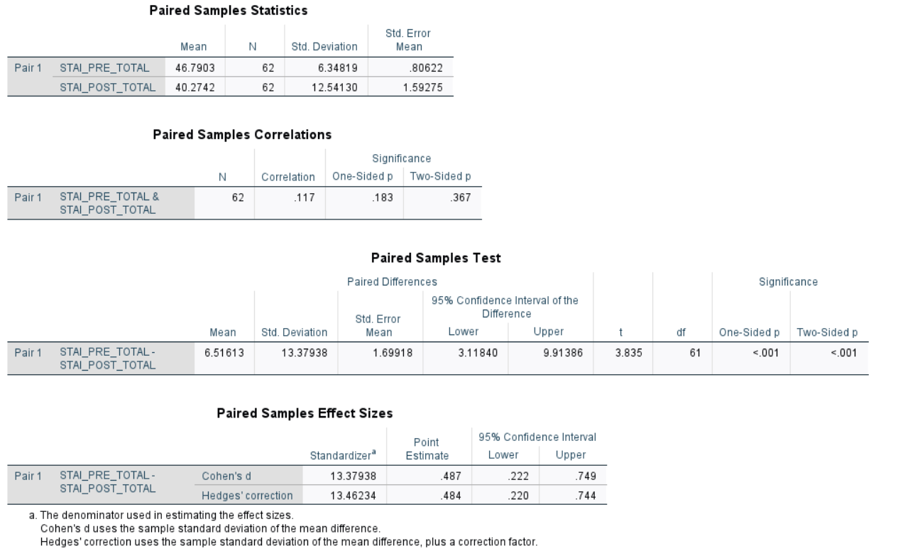
Appendix G
ANOCVA SPSS Output: Neurodivergent (questionnaire)
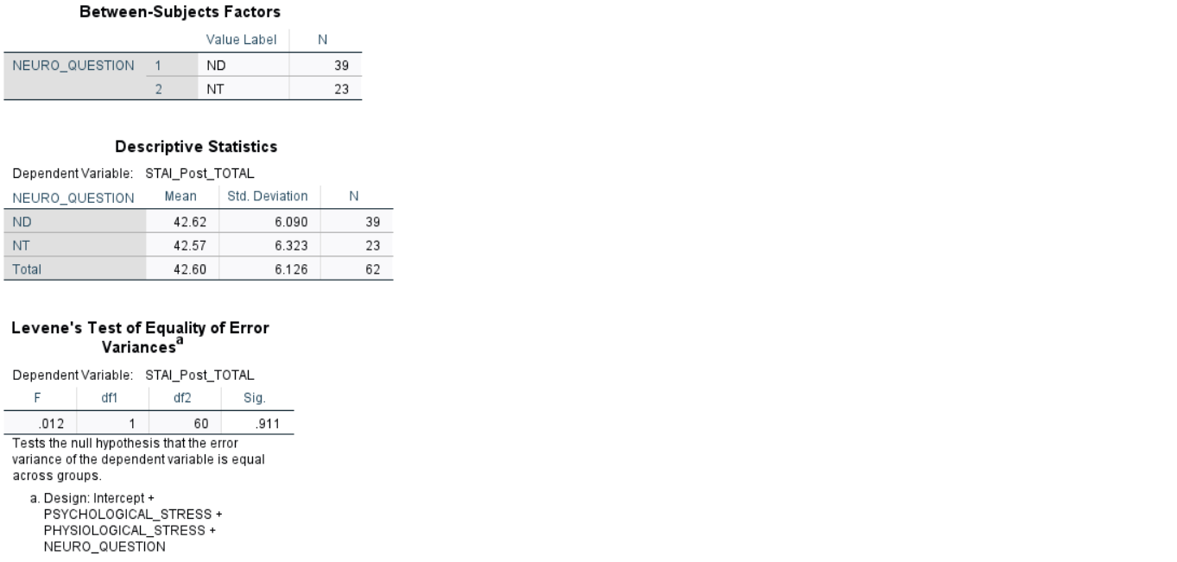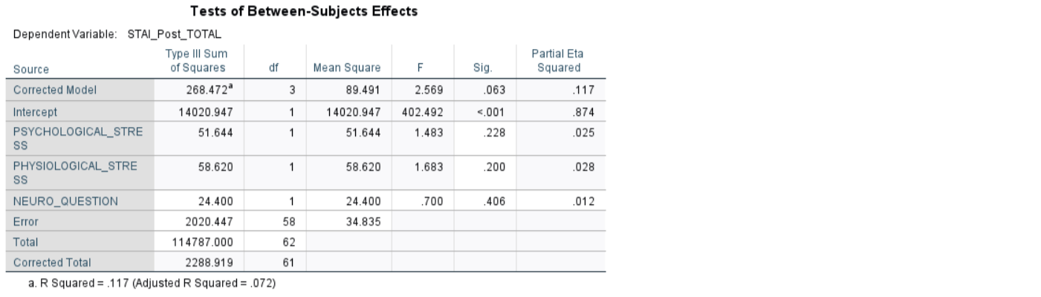

Appendix H
ANOCVA SPSS Output: Neurodivergent (self-report)
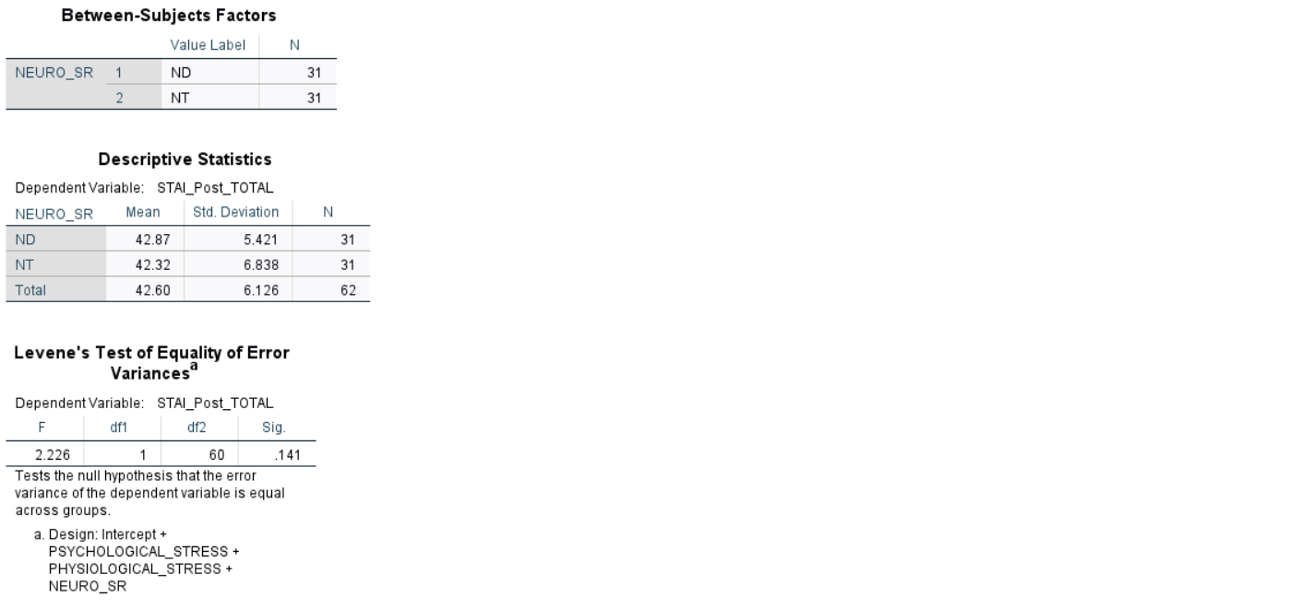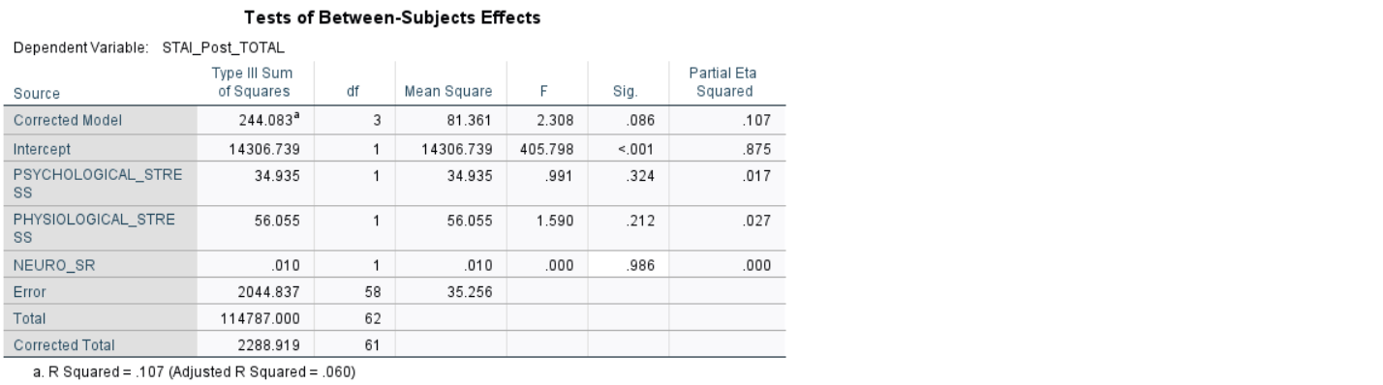
Appendix I
T-test SPSS Output: ASMR Experiencers
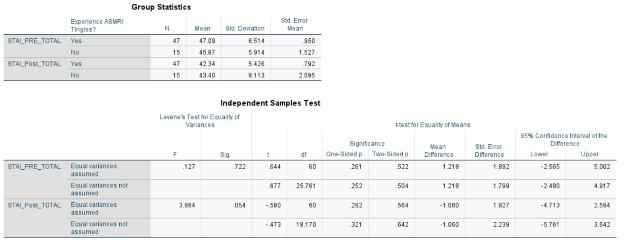
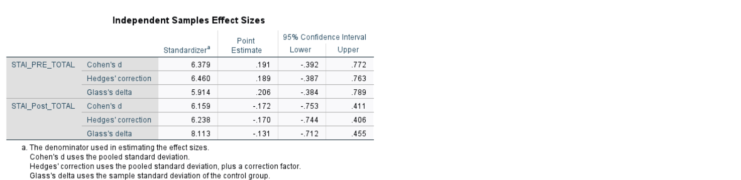
Appendix J
T-test SPSS Output: Gender
